Proposed Experiments: Two-Force Estimation
Objective: Estimate the force configuration vector F = [F₁, s₁, θ₁, F₂, s₂, θ₂] from observed shape data.
Designs Under Comparison
- Baseline: Cylindrical cross-section (r = 1.5 mm)
- Test: Optimized cross-section
Experiment Parameters
A total of n = 60 experiments will be conducted per design. Each experiment applies a two-force loading configuration sampled from the following bounds:
Parameter | Description | Range
F₁ | Force 1 magnitude | [0.1 N, 1.5 N]
s₁ | Force 1 arc-length position along backbone | [20 mm, 200 mm]
θ₁ | Force 1 angle | [0, 2π] rad
F₂ | Force 2 magnitude | [0.1 N, 1.5 N]
s₂ | Force 2 arc-length position along backbone | [20 mm, 200 mm]
θ₂ | Force 2 angle | [0, 2π] rad
Sampling Method
The n = 60 loading configurations will be chosen such that the inter-force separation |s₁ − s₂| is uniformly distributed across its feasible range. This ensures coverage of all separation distances, from closely spaced (hard to estimate) to widely spaced (easy to estimate) force pairs.
Expected Result
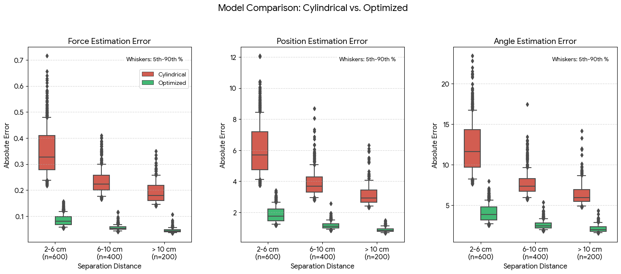
The optimized design is expected to achieve significantly lower average estimation error across all three quantities, force magnitude (F), arc-length position (s), and angle (θ), compared to the baseline cylindrical design.

